Ah-Counter

Helping members off their crutches
The Ah-counter is a crucial member of the evaluation team, which is led by the general evaluator. The purpose of the Ah-Counter is to note any filler words or sounds used by anyone who speaks during the meeting. Words may be inappropriate interjections, such as and, well, but, so and you know. Sounds may be ah, um or er. You should also note when a speaker repeats a word or phrase such as “I, I” or “This means, this means.” These words and sounds can be annoying to listeners. The Ah-Counter role is an excellent opportunity to practice your listening skills.

During the Meeting
Throughout the meeting, listen to everyone for sounds and long pauses used as fillers and not as a necessary part of sentence structure.

- Take note of how many filler sounds or words were used in the meeting in total
- Record a breakdown for each type of filler word used (e.g. 34 ums, 20 uhs, 20 likes…etc)
- Provide total count for each communication project speaker (e.g. speakerA: 21, speakerB: 20)

End of the Meeting
When it’s time to begin the evaluation portion of the meeting, the Toastmaster will introduce GE, who will call upon each member of his/her evaluation team to present their report. When you’re called on by the general evaluator during the evaluation segment, stand by your chair and give your report. You can also provide tips on how you feel the use of filler words can be minimized.
After the meeting is over, remember to ask the general evaluator to evaluate your performance and give you leadership credit in your CL manual.

You may be surprised by the number of filler words used in each meeting. This can be quite natural as many of us don't realize when we happen to use them in speech. This is why it's important to audit this habit and encourage everyone in the club to participate in speeches and practice to minimize it.
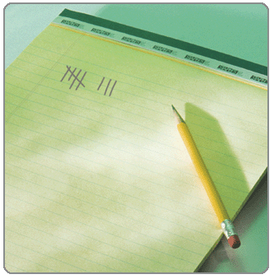
Ref: http://www.toastmasters.org/Members/MemberExperience/MeetingRoles/AhCounter.aspx

